**Creating a SQUIRREL MAIL SERVER**

STEP 1: Install the centos7 in your virtual box

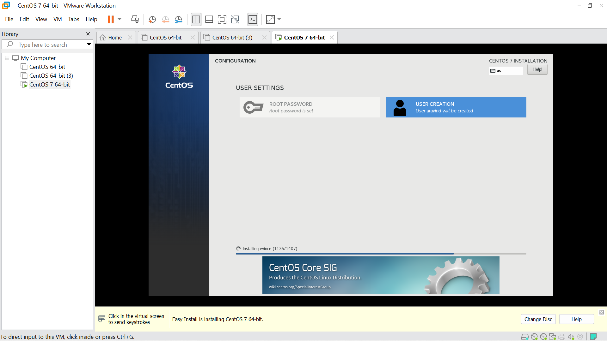

STEP 2:

>open the terminal

>cd

>gedit /etc/hosts

>(your ip address)ipaddress server1.aravind.local server1

STEP 3: DISABLE SELINUX

>gedit /etc/sysconfig/selinux

>Change SELINUX=enforcing to SELINUX=disabled.

STEP 4: Install EPEL Repository:

>yum install epel-release

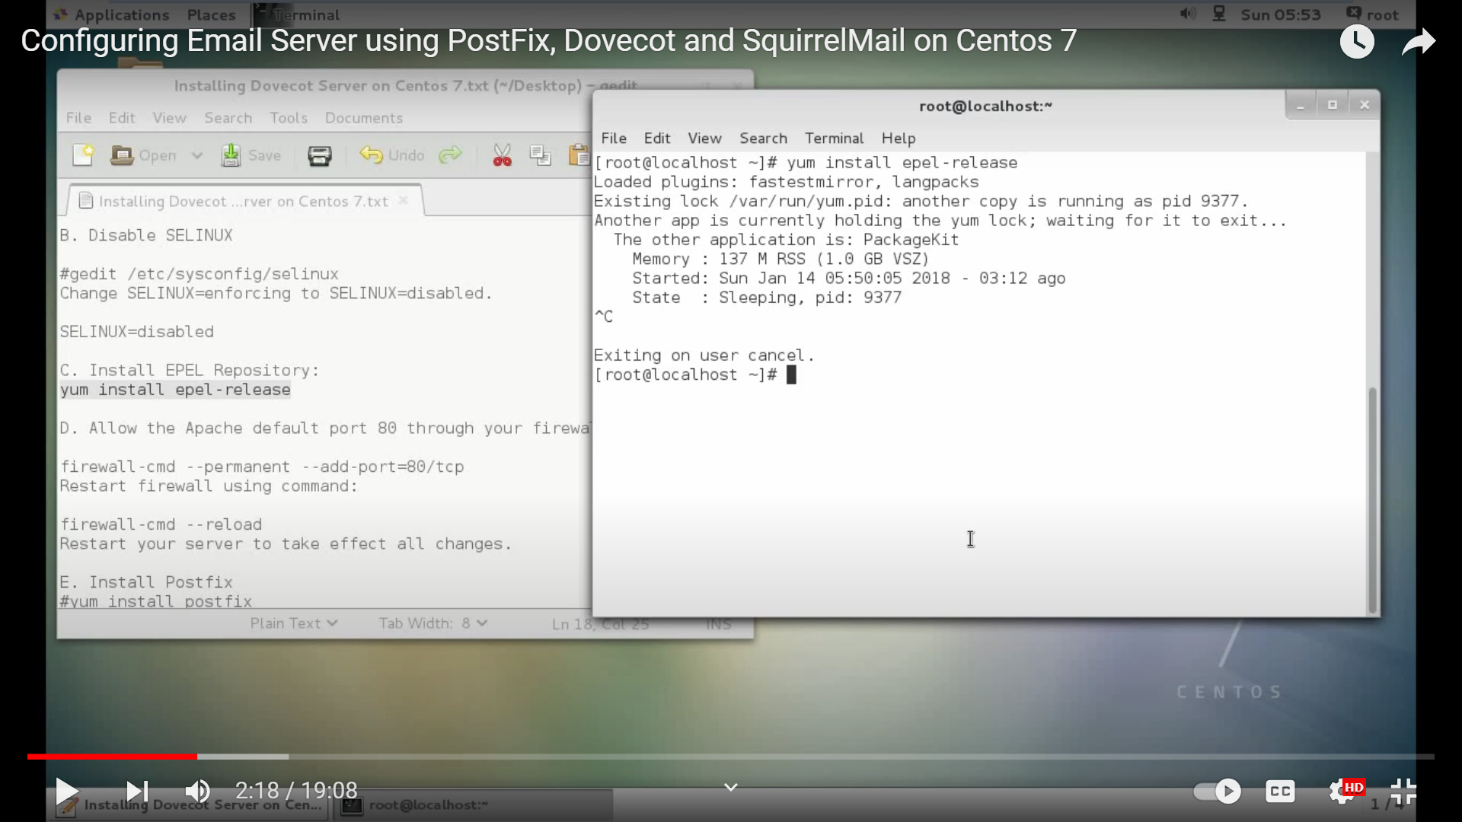

STEP 5: Allow the Apache default port 80 through your firewall/router:

>firewall-cmd --permanent --add-port=80/tcp

*Restart firewall using command:

>firewall-cmd –reload

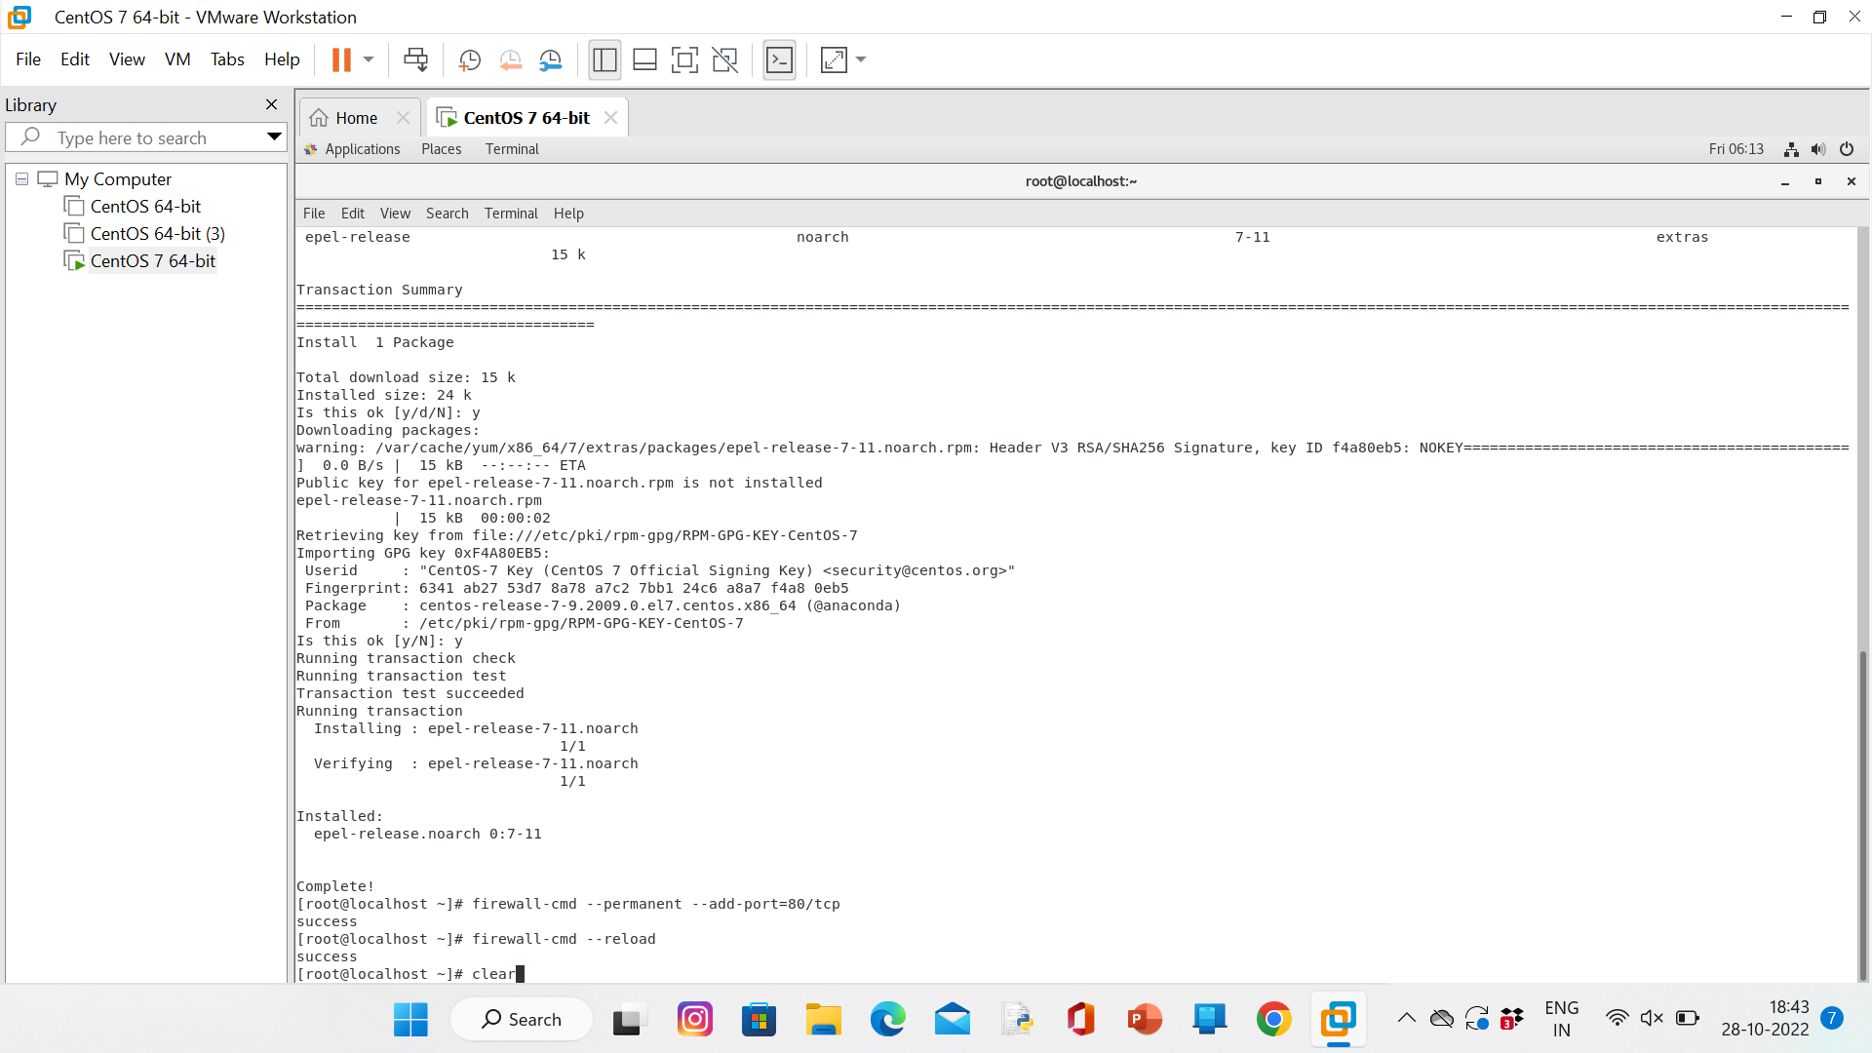

STEP 6: Install Postfix:

>yum install postfix

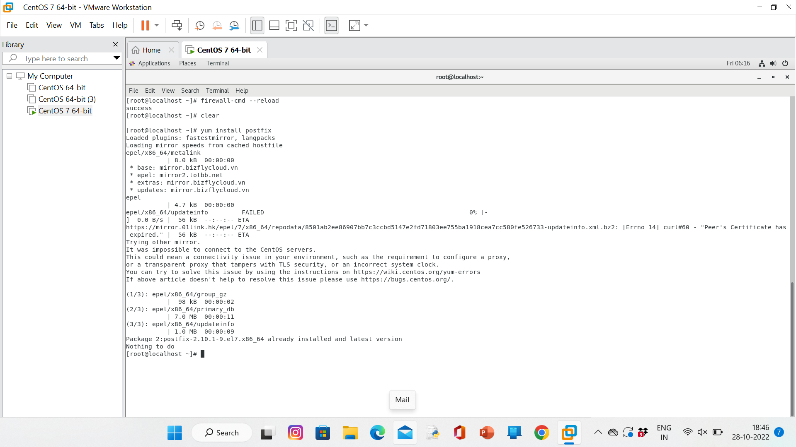

*Configuring PostFix:

>gedit /etc/postfix/main.cf

## Line no 77 - Uncomment it and change your mail server ##(change)

(myhostname = server1.aravind.local)

## Line 85 - Uncomment and Set domain name

##(change)

(mydomain = aravind.local)

## Line 101 - Uncomment ##

myorigin = $mydomain

## Line 115 - Uncomment and Set ipv4 ##(change)

(inet_interfaces = all)

## Line 121 - Change to all ##

(inet_protocols = all)

## Line 166 - uncomment ##

#mydestination = $myhostname, localhost.$mydomain, localhost,

## Line 167 - Uncomment ##

mydestination = $myhostname, localhost.$mydomain, localhost, $mydomain

## Line 266 - Uncomment and add IP range ##

mynetworks = (your ipaddress)/24, 127.0.0.1/8

## Line 421 - Uncomment ##

home_mailbox = Maildir/

Save and exit the file.

STEP 7: Start/restart Postfix service now:

>systemctl restart postfix

>systemctl enable postfix

>systemctl status postfix

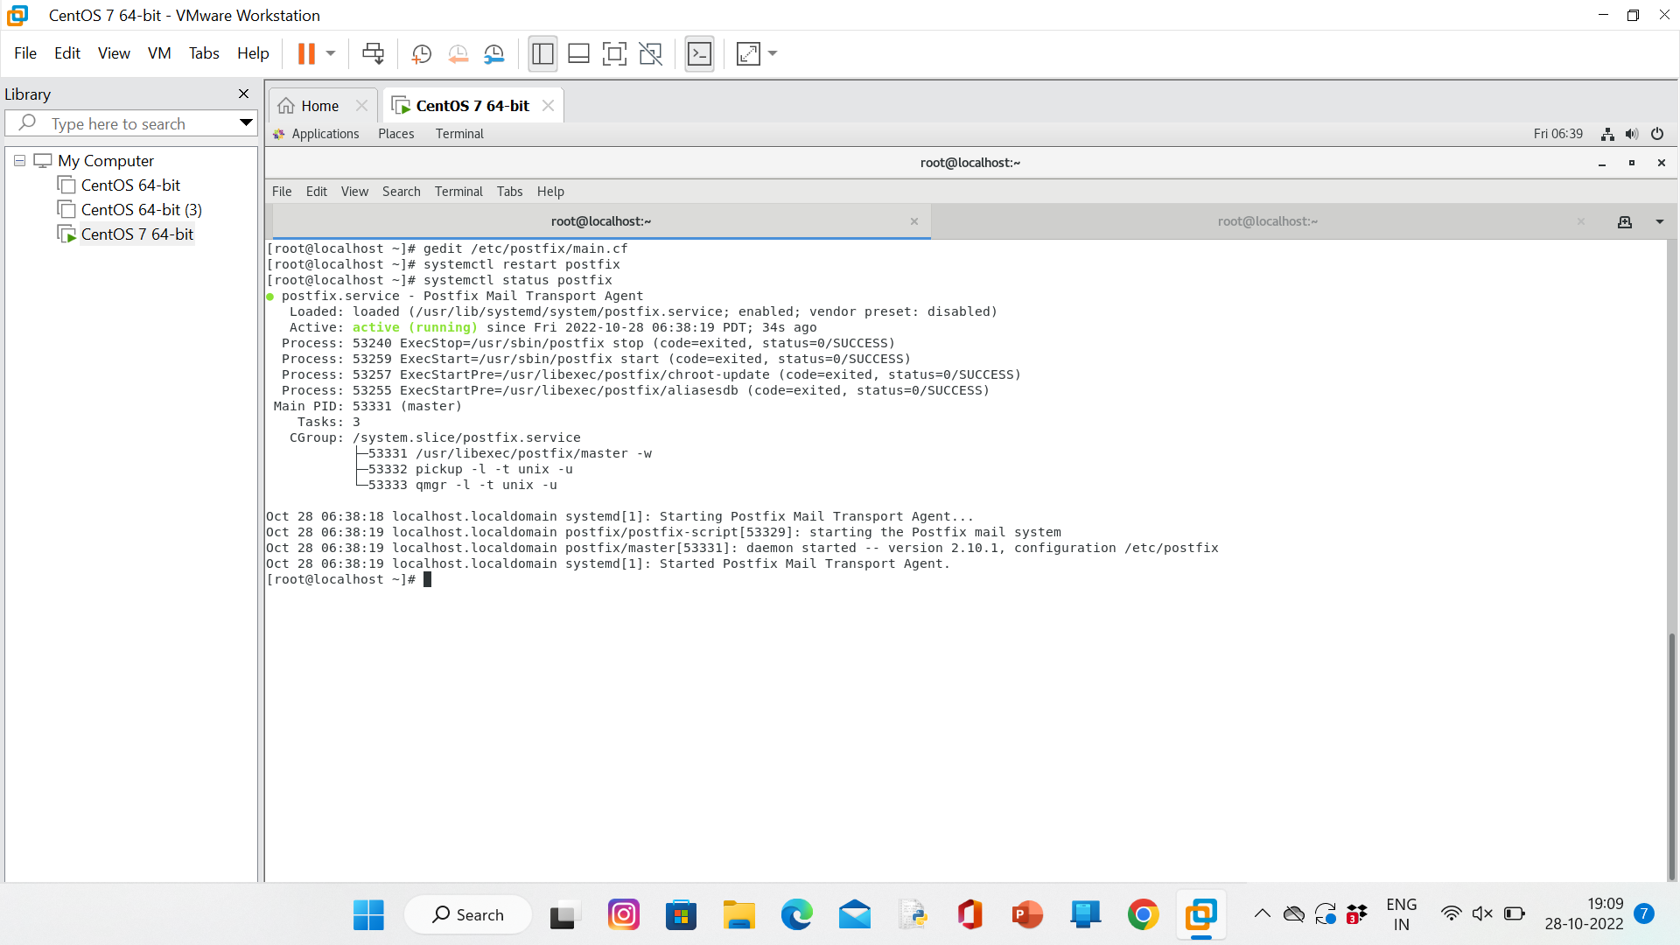

STEP 8: Test the Postfix Server:

>useradd KUMAR

>passwd 12345

IT SHOWS CHANGE NEW PASSWORD

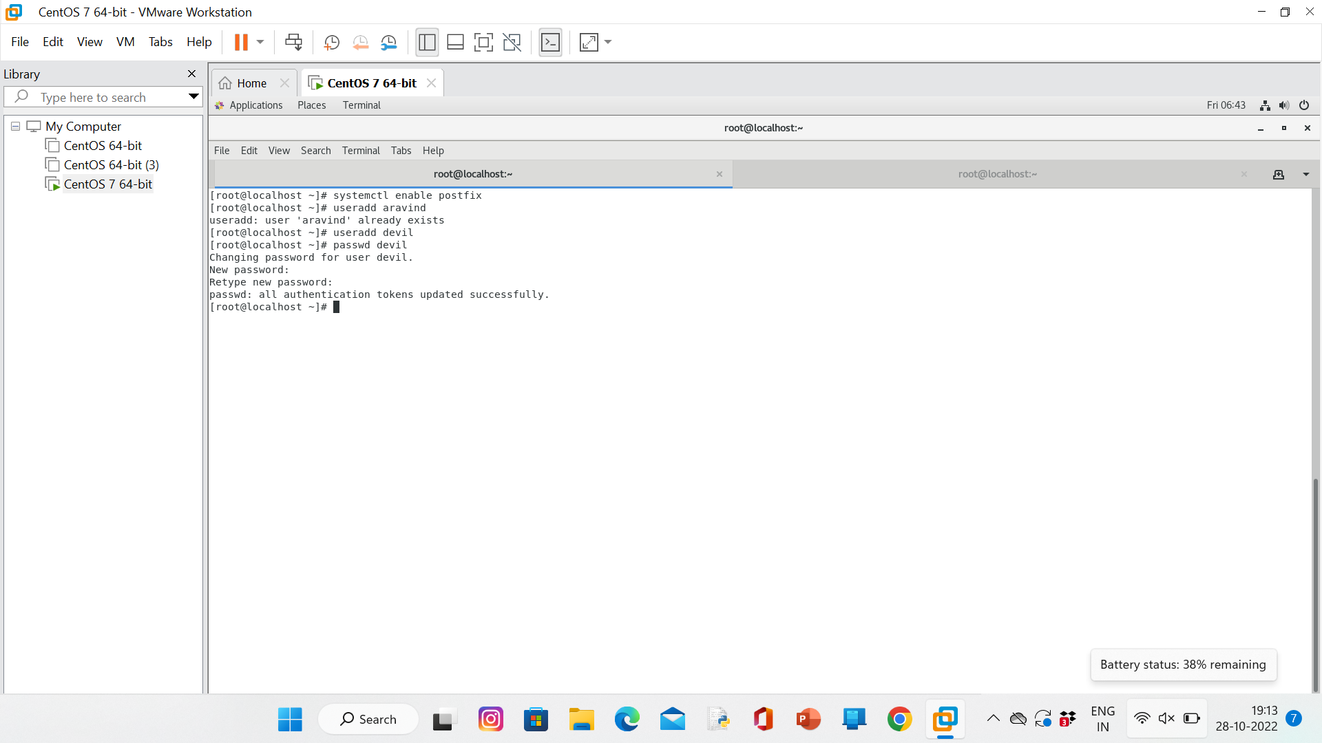

STEP 9: Install telnet:

>yum install telnet

>telnet localhost smtp

>ehlo localhost

>mail from:<KUMAR>

>rcpt to:<aravind>

>mail from:<kumar>

>rcpt to:<aravind>

>data

(Hello Rathinam)

Exit key >(.)dot

>quit

Check weather it is done or not:

>ls /home/anand/Maildir/new/

>cat /home/anand/Maildir/new/(first 3 num of file name) 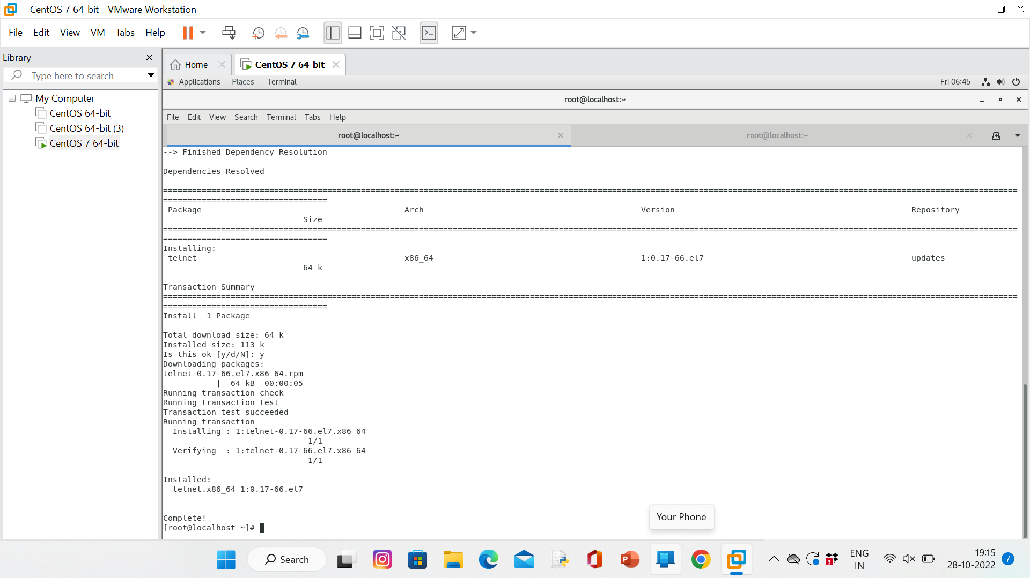

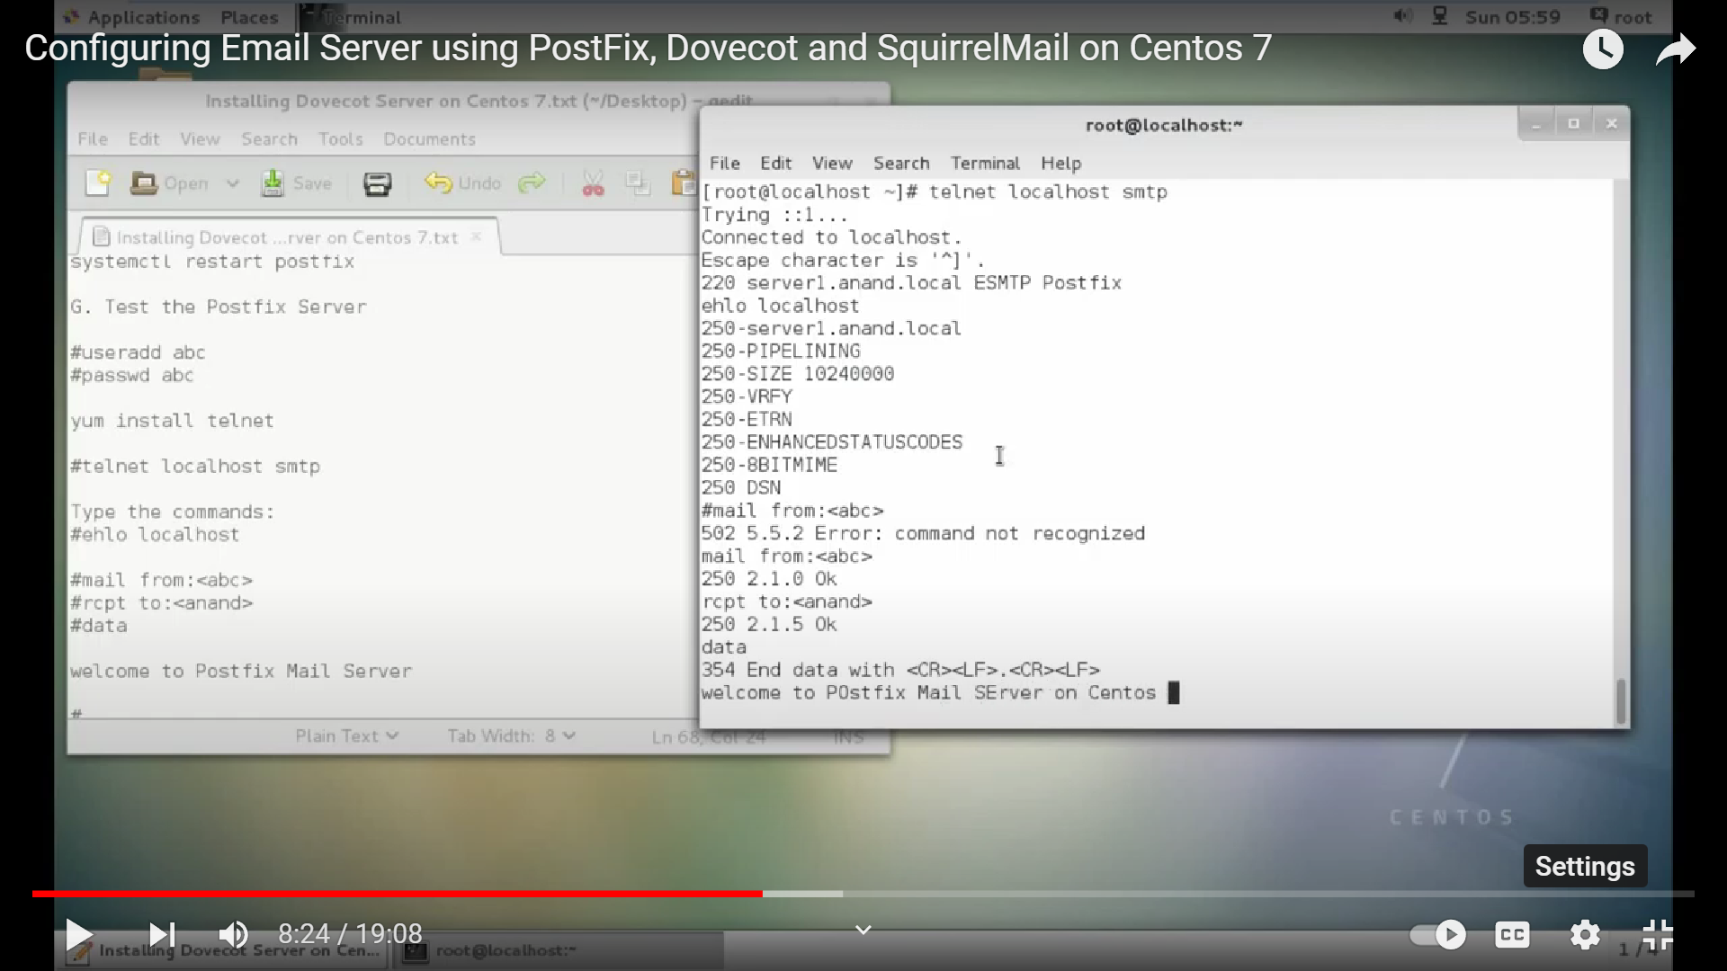

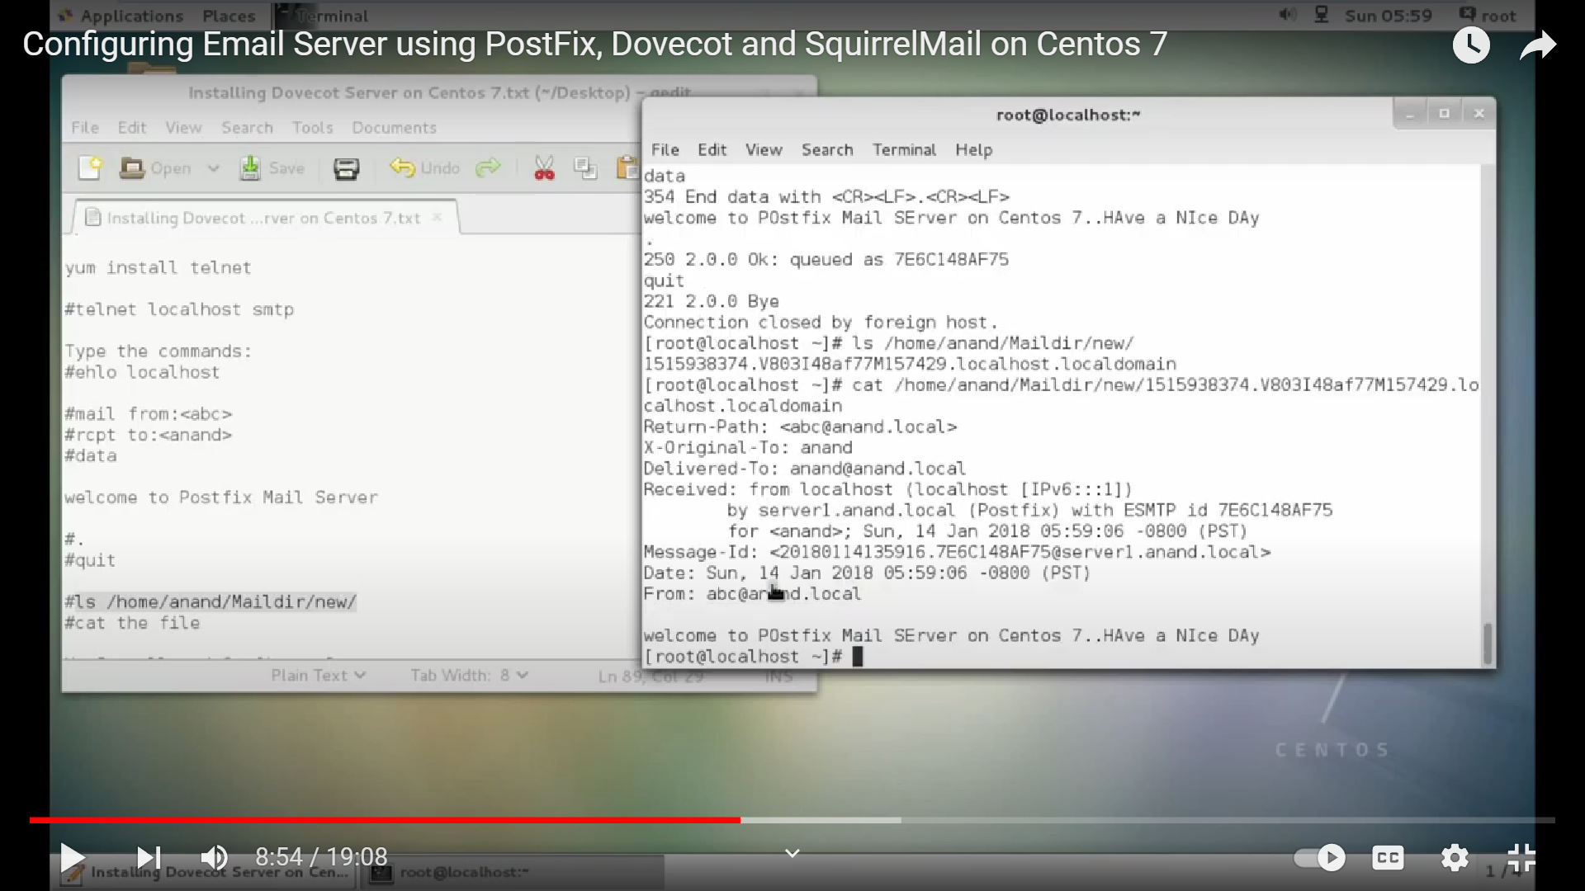

STEP 10:Install and Configure Dovecot:

>yum install dovecot

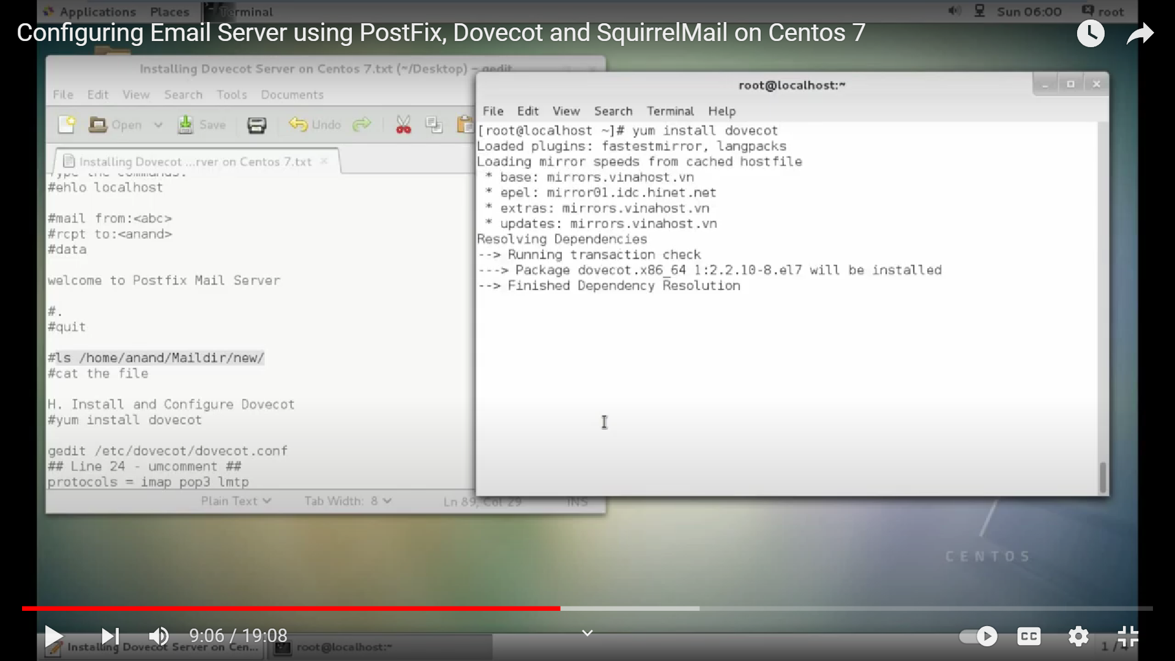

>gedit /etc/dovecot/dovecot.conf

## Line 24 - uncomment ##

protocols = imap pop3 lmtp

STEP 11:

>gedit /etc/dovecot/conf.d/10-mail.conf

Line 24 - uncomment ##

mail_location = maildir:~/Maildir

STEP 12:

>edit /etc/dovecot/conf.d/10-auth.conf

make the changes as shown below:

## line 10 - uncomment##

disable_plaintext_auth = yes

## Line 100 - Add the word: "login" #

auth_mechanisms = plain login

STEP 13:

>gedit /etc/dovecot/conf.d/10-master.conf

## Line 91, 92 - Uncomment and add "postfix"

#mode = 0600

user = postfix

group = postfix

STEP 14: let start the dovecot:

>systemctl start dovecot

>systemctl enable dovecot

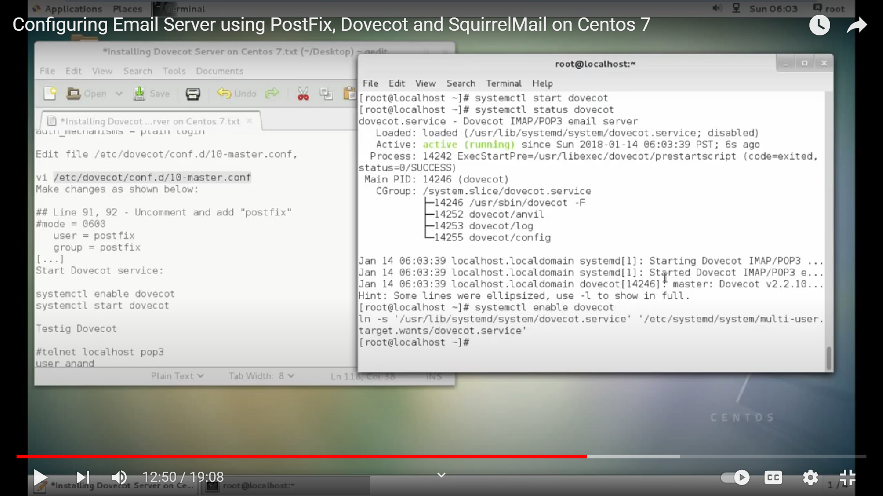

*Testig Dovecot…….

>telnet localhost pop3

User Aravind

Pass 12345

>retr 1

>. (dot)

>Quit

STEP 15: Configuring Squirrel mail:

>yum install squirrelmail

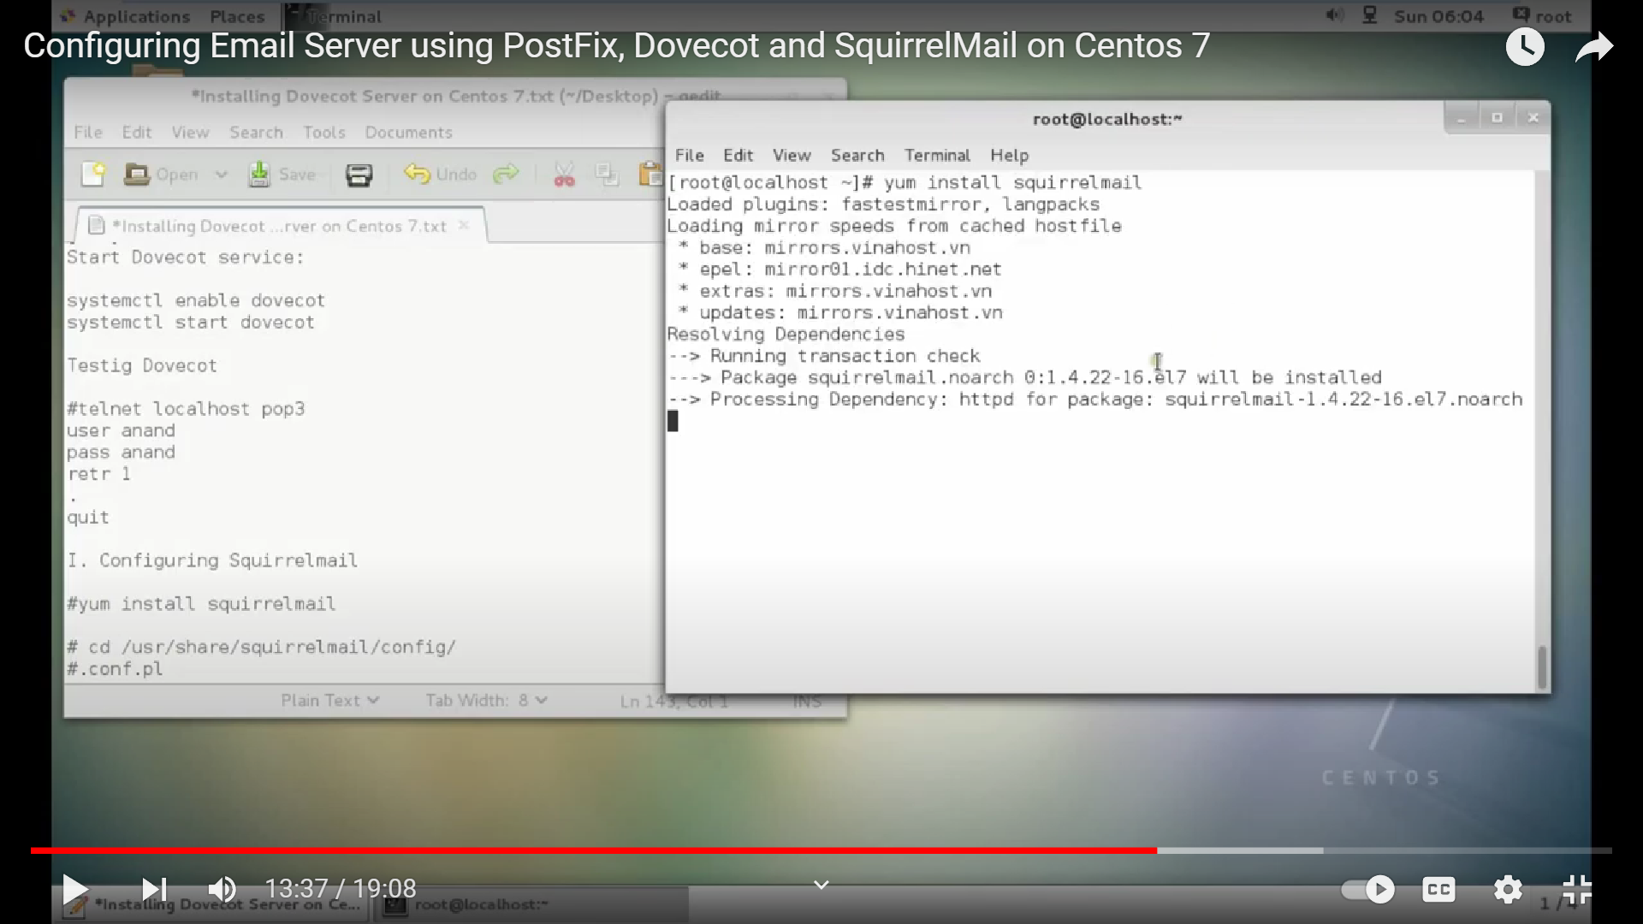

> cd /usr/share/squirrelmail/config/

> .conf.pl

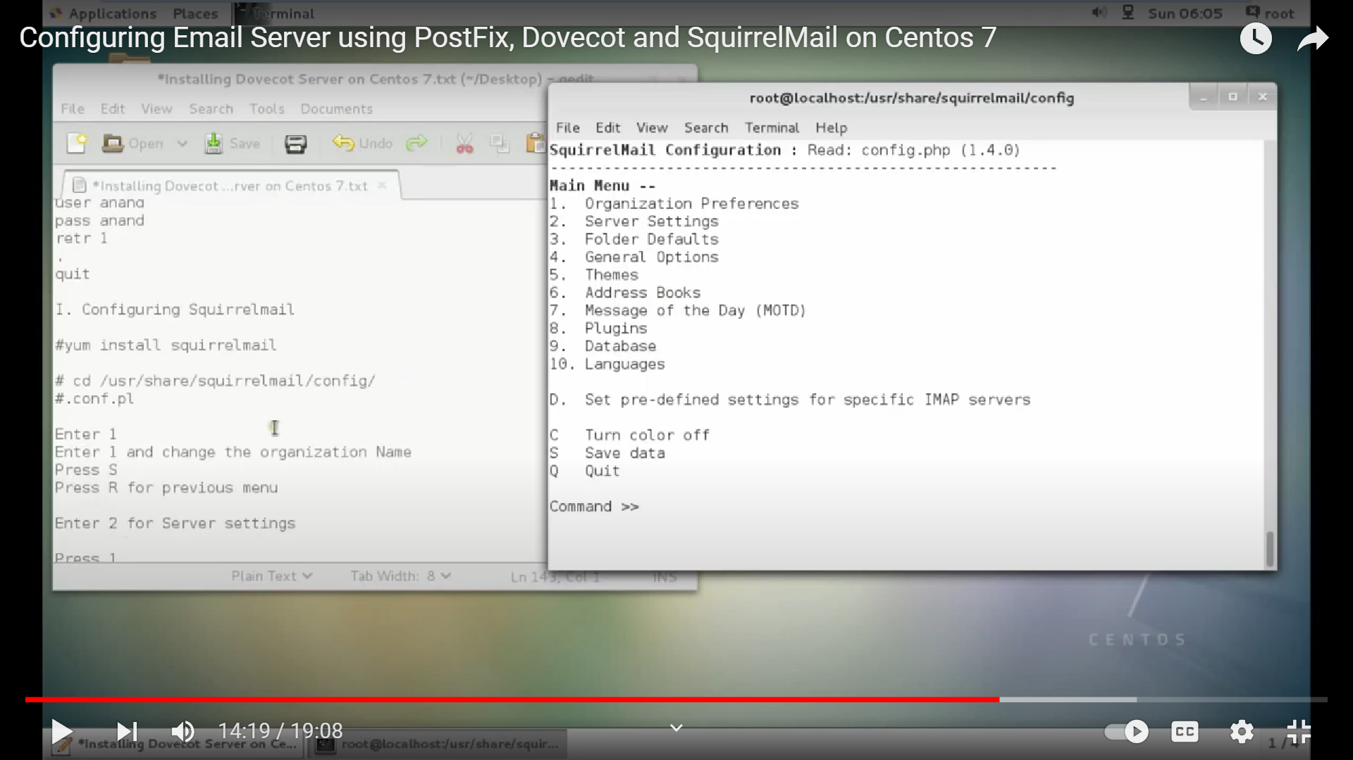

Enter 1

Enter 1 and change the organization Name(Aravind mail)

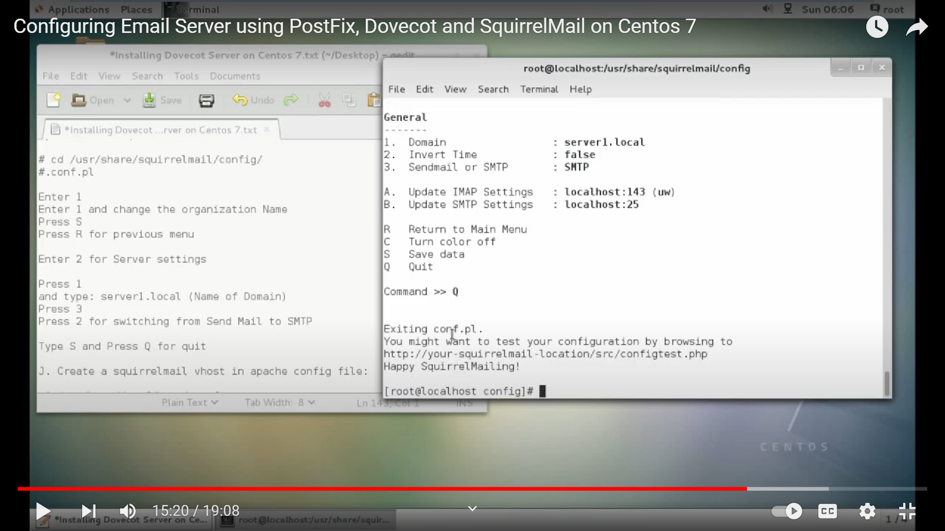

Press S

Press R for previous menu

Enter 2 for Server settings

Press 1

and type: server1.local (Name of Domain)

Press 3

Press 2 for switching from Send Mail to SMTP

Type S and Press Q for quit

STEP 16: Create a squirrelmail vhost in apache config file:

>gedit /etc/httpd/conf/httpd.conf

//Copy this code and paste in the last of the page//

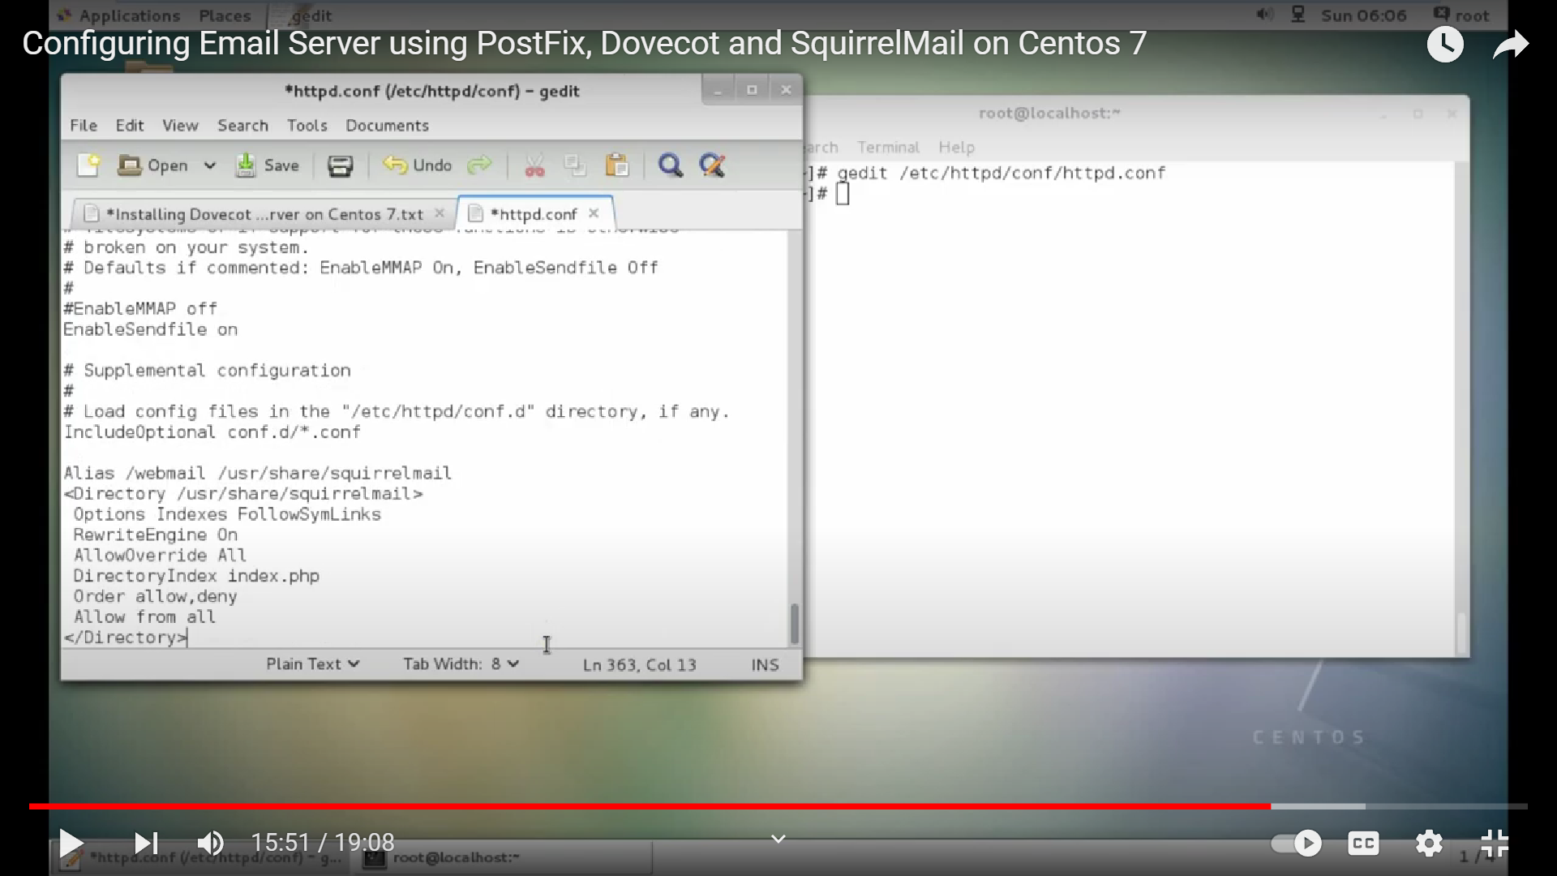

Alias /webmail /usr/share/squirrelmail

<Directory /usr/share/squirrelmail>

Options Indexes FollowSymLinks

RewriteEngine On

AllowOverride All

DirectoryIndex index.php

Order allow,deny

Allow from all

</Directory>

STEP 17: let start the apache server and run the squirrelmail:

>systemctl restart httpd

>systemctl enable httpd

STEP 18: BEFORE START THE SERVER YOU WANT TO ENTER:

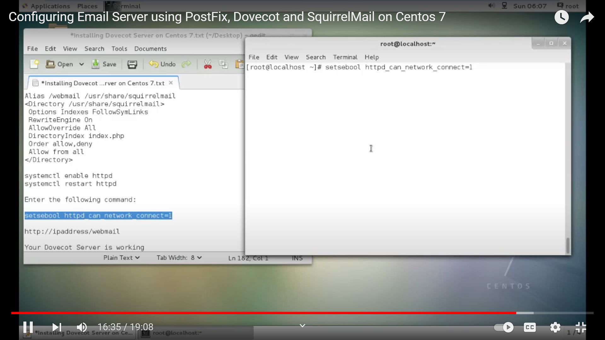

>setsebool httpd_can_network_connect=1

STEP 19: GO TO THE BROWSER AND TYPE IN THE ADDRESS BAR:

>http://ipaddress/webmail

EXAMPLE:<http://192.168.194.196/webmail>

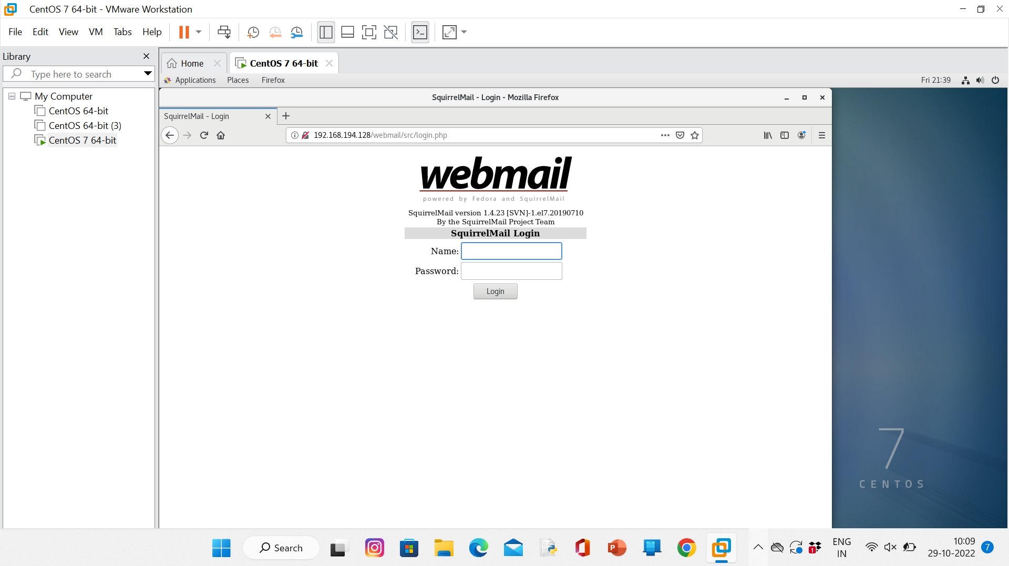

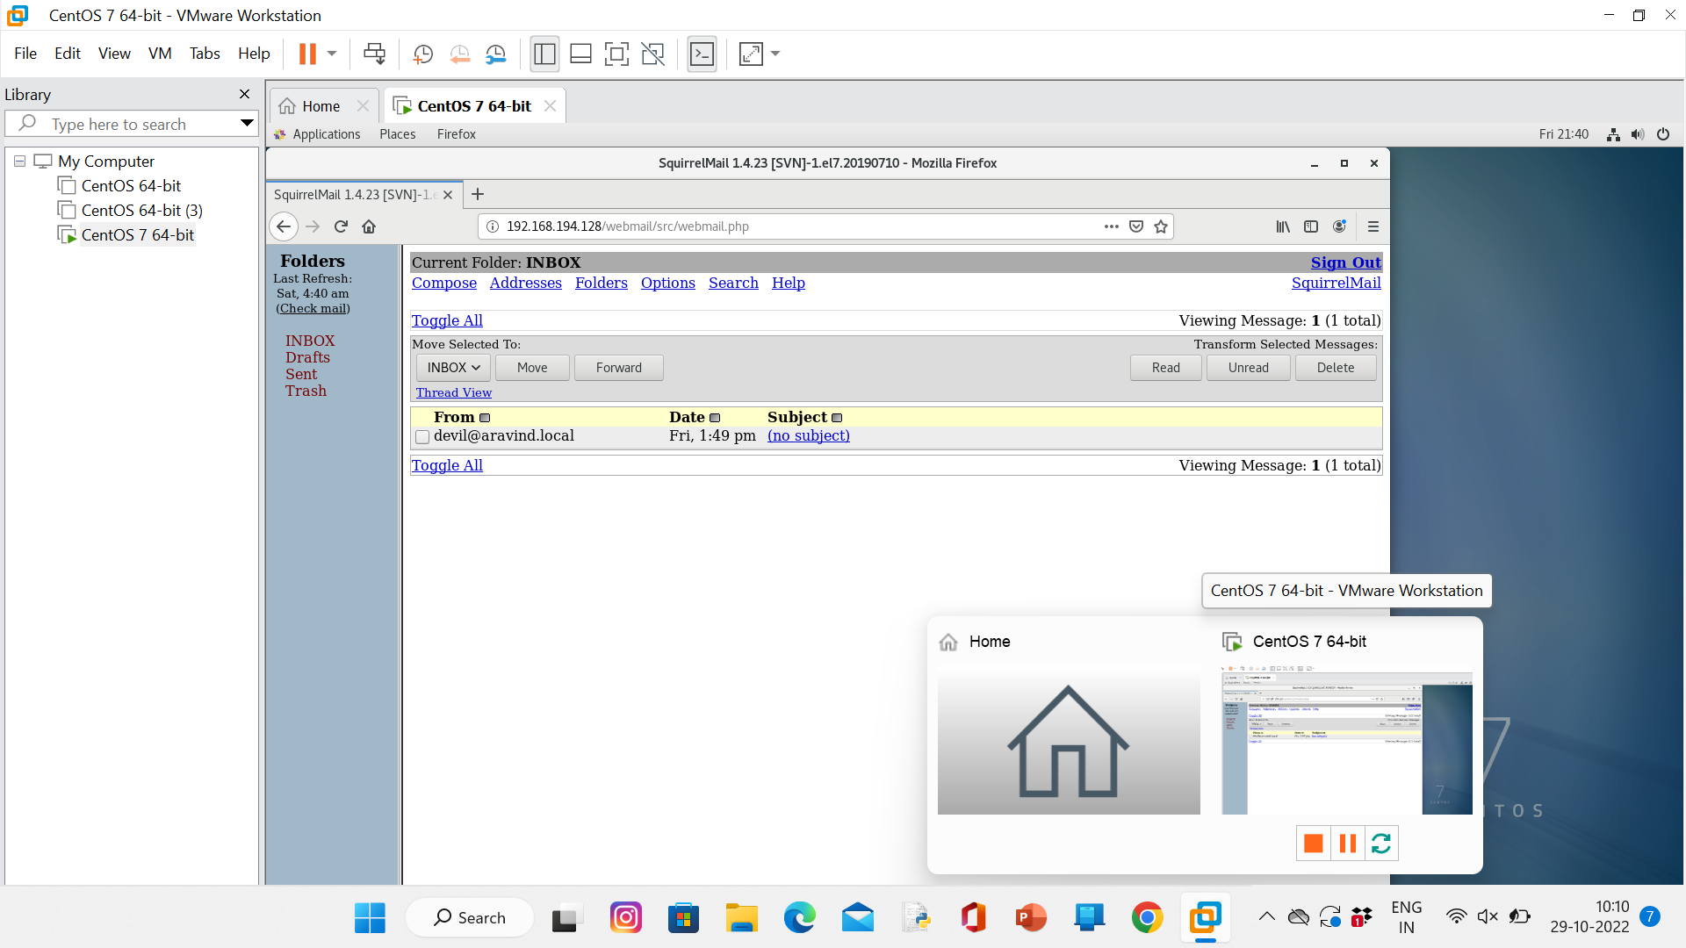

STEP 20: STOP THE PROCESS